**Therapy is hard to find someone who can and [AI innovators](https://imhmdi.com/%d9%87%d9%88%d8%b4-%d9%85%d8%b5%d9%86%d9%88%d8%b9%db%8c-%da%86%d9%87-%d8%b1%d8%a7-%d8%aa%d8%b4%d8%ae%db%8c%d8%b5-%d9%85%db%8c%d8%af%d9%87%d8%af%d8%9f/) and [machine learning view](https://imhmdi.com/%db%8c%d8%a7%d8%af%da%af%db%8c%d8%b1%db%8c-%d9%85%d8%a7%d8%b4%db%8c%d9%86-machine-learning-%da%86%db%8c%d8%b3%d8%aa%d8%9f/) surprise him Although this technology is still in its infancy, its models and algorithms are already capable of many tasks. They can do anything. Using highly personalized services for the audience to create highly creative paintings. Solutions based on artificial intelligence and machine can be profitable for all industries .** [**The stock market**](https://imhmdi.com/%da%86%da%af%d9%88%d9%86%d9%87-%db%8c%d8%a7%d8%af%da%af%db%8c%d8%b1%db%8c-%d9%85%d8%a7%d8%b4%db%8c%d9%86-%d9%85%db%8c-%d8%aa%d9%88%d8%a7%d9%86%d8%af-%d8%a8%d8%a7%d8%b2%d8%a7%d8%b1-%d8%b3%d9%87%d8%a7/) **, real estate, is definitely one of these industries .**

**There are many jobs in real estate where machine algorithms can be useful. As it can be used to predict real estate prices and, for example, the price change of a particular property in the future. It helps brokers (brokers) to make the market and plan their strategy based on real information. And we are lucky to be working on such a solution. In this article, we have mentioned our experience of building a machine model to predict real estate prices .**

**The numbers that should be used to predict real estate prices They paid attention**

**Let us share some interesting statistics that show what the real estate industry in the United States looks like. Then we can generalize these statistics to our own country :**

* **New York, San Francisco, and Chicago have the least competitive markets in the United States . (Zillow)**
* **The prices of newly advertised houses in the United States have increased by 13.5% compared to March of last year and by 26.5% compared to March 2020 . (property broker)**
* **The number of days that houses remain on the market is decreasing. In March 2022, this statistic was 38 days and in March 2021, it was 49 days . (National Association of Real Estate Consultants)**
* **And here's the most interesting one: those born in the 1980s to 200 are the biggest homebuyers in the market. Those born between the 1960s and 1980s are the largest market with 24% of the total . (National Association of Real Estate Consultants)**

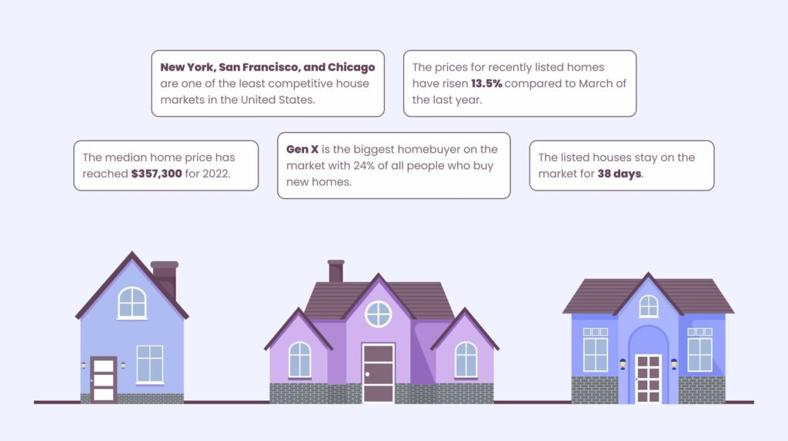**An infographic of the real estate market in the United States**

**All these statistics and trends play an important role in predicting real estate prices. Now we're going to move on to the machine learning name option that we'll use more often. Options where all statistics were useful .**

**Real estate price prediction model: Why create it?**

**Real estate price prediction is different for each house and predicting its behavior in the future. Even though this forecast only covers a short period of time, many factors can affect the final numbers. Two of the most important ones are :**

* **Prices of homes with similar features that have recently sold .**
* **Mastery of market trends**

**Based on the previous section, I can see that both of these can change drastically over time and some features can be seasonal. In addition, in predicting real estate prices, many features are related to the house itself: the number of bedrooms, the age of the building, the general condition, the quality of the neighborhood, the proximity to shops, schools, entertainment and many other things .**

**It is also worth mentioning that a professional about the price of a property can be in the following form :**

**Comparative market analysis**

**Realtors look for similar homes in the area and determine the value of a property based on how those homes are priced in the market. Similar houses are selected based on the size, number of rooms, architectural style and selling price .**

**Broker opinion for price**

**Broker Price Opinion (BPO) is another option for people to know the expert price of a property. This pricing is usually done by a professional broker who knows the local market. This method is common for short sales, foreclosures, and listing prices for listings and sellers. And it is less useful for predicting real estate prices in the long term .**

**The amount a broker should be when predicting real estate prices can be overwhelming. This can be overwhelming for even the most experienced real estate professionals. In addition, there is still the possibility of human error .**

**The reason we started working on this project was because a guide asked us: to automate real estate price forecasting and minimize human error. Our main goal was to build a very accurate machine model that would predict house prices within a month with an accuracy of 85-90 % .**

**How did we build a model to predict real estate prices?**

**The main questions that arise in this context are: what we did to create a machine model for predicting real estate prices, what technology stack is used, and what challenges are faced during the work process. we became Let's start with the overall strategy. Our route went as follows :**



**1- Data collection**

**Our first source of data was our customers themselves. They provided us with a set, however this data was not enough to train a real estate price prediction model. To solve this problem, they started their research on other sources that can provide us with real estate. We use information sources related to the market in the United States, as well as information related to the country's economic conditions, so that we can achieve a set of data that represents the real state of this market .**

**2- Engineering feature**

**To predict real estate prices, select the following features :**

* **Changes in the price of each property over time**
* **Property location**
* **Type of house**
* **Neighbors**
* **To have a pool or not**
* **Other non-traditional factories**

**3- Setting meta parameters**

**Metaparameters act as an extra help during the process. They are out of the model; It means that they are imposed on it and do not have the power to change it in any way. They are also only used during training and do not complete the model itself. After passing this stage, we have things to validate the results of the model, control its behavior and maximize its performance .**

**4- Studies _**

**During the entire model training process, we were constantly evaluating and marketing the impact and relevance of each experiment. These predictions are done in order to increase the accuracy of the real estate price prediction model as the final solution .**

**5 - Repetition**

**When the version finishes, we restart the model to refine the model and make sure its results are as accurate as possible .**

**technology stack (stack technology)**

**Our main tool XGBoost Was. An open source decision making library (decision tree with modified) for the machine. We used that regression model. Others on our list were :**

* **Python 3.7 - programming language**
* **Pandas – data cleaning and analysis**
* **Scikit-learn - classification and prediction analysis**

**This set of tools helped us to achieve the desired accuracy .**

**The main challenge in building a real estate price prediction model**

**Nothing in this world is perfect and our machine learningdevelopment process is no exception. For the most part, the process was quite predictable and fluid. But at one point, we were faced with the challenge of disproportion. Since the initial set of values did not have quality and was very small, it was difficult for the algorithm to find hidden trends and calculate accurate results .**

**As mentioned earlier, our solution for building a real estate price prediction model was found in third-party data sources. The information we find in public sources helps us get back on track and train the model properly .**

**The results of the real estate price prediction model**

**The results were even better than we expected. Customers should expect accuracy to be around 85 % of actual prices, but we achieved 91 % accuracy . Yes, 1 % is not very much, but considering the circumstances, we cannot expect a better result .**

**Was it successful?**

**In short, yes. It was like that. The model was not perfect, the initial data were not the best, and there was a lack of fit. But anyway, it was a good start. We have to see that the machine will be a permanent technology in real estate and we can easily work on more stages of it. Besides, real estate price forecasting is not the only areas I can work on. The applications of this technology can include search files and real estate evaluation .**

Amirshayan Jalili

[Shayan138190@gmail.com](mailto:Shayan138190@gmail.com)

<https://github.com/Amirshayan2002>